**Perspectives on Urban Theories**

### **Abstract**

Urban systems intrinsically need multiple complementary theories to be understood. This concluding chapter synthesizes the approaches developed in the book and aims at showing their complementary nature and how new approaches making bridges can be developed. We first provide a broad overview of the theories and disciplines that the viewpoints developed in the book link to. We then extend this synthesis through citation network analysis, reconstructing a citation network from the references cited by authors, and identify disciplines from community detection within this network what allows to discuss the relative positioning of approaches. We finally discuss how modeling and simulation could be a systematic entry to the coupling of theories, and recall best practices in this particular context of building integrative complex simulation models of social systems.

**Keywords :** Urban theories; Urban models; Simulation model coupling

### **Introduction**

### **Complementary urban theories**

section par Denise : synthesis of the book, thematic link between theories used by the different chapters, positioning of disciplines and their relations (can insist on sociological aspects of science, as citation network analysis in the second section is a very reductionist view of the question)

### **Citation network analysis**

We now turn to a quantitative analysis of the relative positioning of disciplines and approaches discussed above. We propose to use citation network analysis as a proxy to understand the structure of that scientific environment, what captures a single dimension of practices but contains relevant information on endogenous disciplinary structures. We use the method and tools of (Raimbault, 2019) to construct a citation network at depth two, from the references cited by chapters of this book. The rationale is to reconstruct from the bottom-up the scientific legacy in which each approach situates itself (a citation is a subjective and positioned asset to provide a basis for further knowledge), what is indeed not fully overlapping with the actual content (e.g. captured by semantics, as (Raimbault et al., 2019) shows how the two quantifications are complementary).

The bibliography of each chapter was manually indexed to ensure correct citing references retrieval during the data collection process. Furthermore, for performance purposes, but also to ensure a focus of the network content on urban issues, references clearly out of the scope and which would yield a significant part of the initial network totally unrelated to urban theories (the paper on morphogenesis by (Turing, 1990) is a typical example, being anecdotally cited by papers relating to urban issues, but also massively cited by several branches of biology). Code and results, on the open git repository of the project at https://github.com/JusteRaimbault/Perspectivism/ tree/master/Models/QuantEpistemo. The raw dataset of the corpus is available on the dataverse at https://doi.org/10.7910/DVN/QCSAKT.

The initial corpus contains N = 402 references, and from it the backward citation network at depth two is reconstructed, yielding a network with V = 596,318 nodes and E = 1,000,604 links. We then keep the largest connected component (covering 99.98% of the network) and work on the higher order core of the network, obtained by removing nodes with degree one until no such node is present anymore in the network. The resulting network is smaller (159,648 nodes and 563,956 links) but expected to contain important information in terms of topological structure. A community detection algorithm (Louvain method at fixed resolution of 1) on the symmetrized network is used to reconstruct endogenous disciplines from the viewpoint of citation practices. We obtain 27 communities which have a directed modularity of 0.71. Their size distribution is particular: 16 of them have a cumulated size of less than 1% and can be ignored in the analysis, while the remaining have a rather low hierarchy (rank-size exponent of -0.68 +- 0.08 with an adjusted r-squared of 0.88). This means that communities are rather balanced, confirming that this book covers a broad range of topics with no topic particularly dominating. The main communities are described in Table 1, with their name given after inspection of highest degree papers, their relative size, and some representative papers (chosen among the ones with the highest degree).

**Table 1 | List of largest citation communities** (covering more than 90% of the network). The name of each was given after inspection of papers of highest degree within the community. we give for each some representative papers among these (degree in brackets).

|  |  |  |
| --- | --- | --- |
| **Community** | **Relative size (%)** | **Representative papers** |
| Regional science | 18.00 | (Cooke & Morgan, 1999) [935] ; (Porter, 2000) [990] |
| Planning/Governance | 12.48 | (Bulkeley, 2013) [541] ; (Healey, 2006) [737] ; (McCann, 2011) [538] |
| Economic Geography | 12.33 | (Gabaix, 1999) [957] ; (Henderson, 1974) [831] |
| Social geography (health, public space, built environment, mode choice) | 11.54 | (Handy et al., 2002) [666] ; (Gehl, 2011) [722] |
| Complexity / Urban simulation / Geosimulation | 8.94 | (Batty, 2013) [642] ; (Waddell, 2002) [893] ; (Benenson & Torrens, 2004) [535] |
| Pattern Design | 7.7 | (Alexander, 1977) [993] |
| Microdemographics | 6.1 | (Bongaarts, 2002) [370] |
| Mobility | 4.6 | (Cresswell, 2006) [701] |
| Transport Networks | 4.2 | (Rodrigue et al., 2016) [438] |
| Spatial Analysis | 4.0 | (Anselin, 2013) [493] |

The content of community obtained correspond to some extent to broad disciplinary trends, but also to some thematic structure with some being apparently rather “interdisciplinary”. The largest community (called “Regional science”) contains works on innovation, firms, clusters, and regions, that we attribute to regional science, that can be considered as a branch of urban economics working on these particular objects and scales. A second community includes work in planning, but also on governance structure and impacts of these (on climate change for example (Bulkeley, 2013)). The next cluster is Economic Geography, as an expected strongly disciplinary cluster. Then comes works related to social issues, on very different topics (from health to the use of public space, built environment, or transportation mode choice) but all related to the study of the human and social component of the city. An important cluster is then related to complexity and simulation approaches, which can be interpreted more as a “methodological” community. Finally smaller communities can be thematic (Microdemographics, Mobility) or methodological (Spatial analysis). The smallest communities have more chance to being contingent to particular choices or subjects chosen by authors of the book, but the largest components can be seen as a broad overview of urban theory in general. Note that these results remain a partial mapping of urban theories and that many entries remain out of our analysis (urban climate or hydrology for example, population microsimulation models, or purely architectural or urban design approaches, to give a few).

**Fig. 1 | Visualization of the core citation network.** The network is visualized using the Gephi software, with a Force-Atlas 2 algorithm for the spatialization. In this algorithm, attraction forces are mediated through links, thus the spatial proximity between two communities relates to a proximity in number of links, and the relative positioning but also the compactness of communities can be interpreted. Color of nodes give communities (orange: regional science; light green: economic geography; light blue: governance/planning; pink: social geography; red: mobility; purple: design; dark green: complexity; beige: demographics).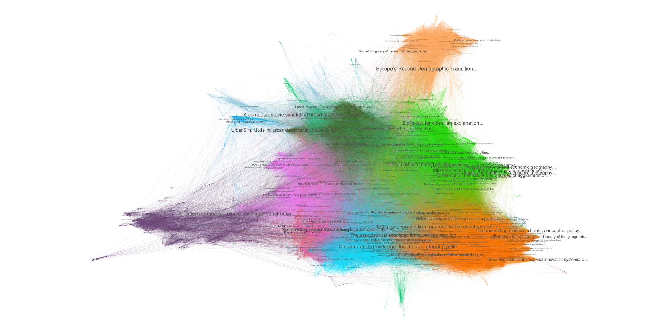

We visualize the network in Fig. 1 in order to have an overview of how the different communities relate to each other. Without surprise, regional science, economic geography, and planning interact strongly and form a very compact triangle. Social geography (in which we can include mobility), and complexity connect also strongly to this core, social geography being mostly connected with planning and complexity, while complexity makes the bridge between economic geography, planning and social geography. Finally, some communities are more isolated at the periphery, such as design or demographics. This visualization confirms that the theories considered in this book are well balanced and relatively well integrated, at least at such a scale of the full network.

The content of largest communities can be studied more precisely, what can also give a better grasp on their level of interdisciplinarity. Therefore, a second community detection can be run within each. The level of modularity then gives if each is well integrated or if it can be decomposed into subfields. As expected, subnetworks are still relatively modular, but with different strengths. Regional science is the less modular with a modularity of 0.49, economic geography is also relatively low (0.59), while planning (0.63), social geography (0.66) and complexity (0.63) are the most modular. This can be interpreted as for example economic geography and regional science being more monolithic. To illustrate how subfields organize, we show in Fig. 2 a visualization of the subnetwork obtained by keeping the “complexity” community only. We observe a continuum between practical approaches (urban sprawl (Nechyba & Walsh, 2004) and urban growth (Seto et al., 2011) at the bottom), dominating applied simulation approaches (largest communities in the middle, corresponding to models such as Land-use transport interaction models on the left (Waddell, 2002), and cellular automata models on the right (Clarcke & Gaydos, 1998)), and more methodological and theoretical approaches at the top, including geosimulation (Benenson & Torrens, 2004), agent-based modeling (Schelling, 1971), urban complexity (Batty, 2007), and urban systems (Pumain, 1996). It is noteworthy to observe the diversity of these “sub-disciplines”, but also their complementarity since applied models rely on theoretical and methodological investigations on one side, but also on data-driven investigations on the other side. Furthermore, to connect this diverse community with the rest of the full networks, each sub-community will play its own role in introducing bridges (e.g. applied models will connect to planning, while complexity approaches can connect with economics).

**Fig. 2 | Visualization of the subnetwork for complexity/simulation models.** Visualization process is the same as before. We observe here communities ranging from data analysis to theoretical and methodological complexity approaches, with applied models in the middle.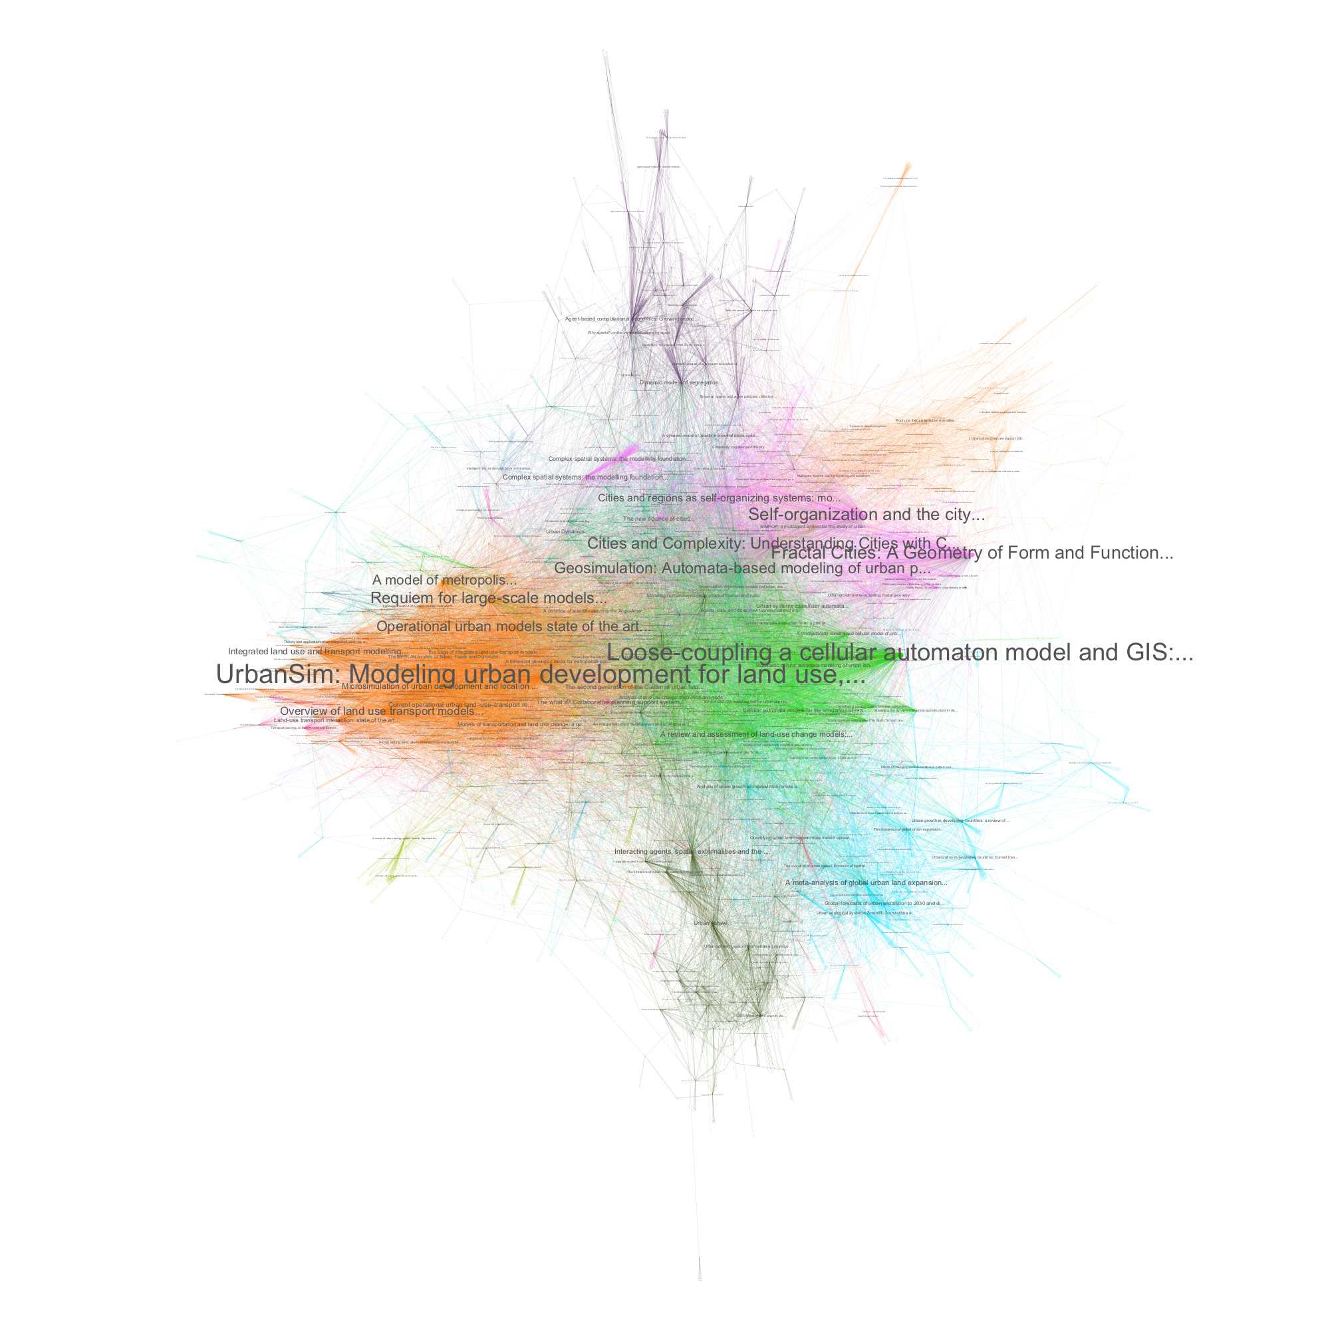

We did up to here a mostly visual and descriptive analysis, but it is also possible to quantify the relation between the endogenous disciplines identified, to understand the effective bridges existing or potential integrations. We use for this a basic indicator of inter-citation proportions. Given a total number of citation links made by a given community, we evaluate the proportion of these links made to a paper in another given community. The corresponding matrix for the 5 largest communities is shown in Table 2. The values confirm highly clustered communities, with all having an internal citation rate largest than 77%, the largest being regional science with a rate of 89%. This suggest potential for more bridges (although we quantify here only “direct bridges“ and may miss some intermediate role that would be revealed by centralities e.g. - such an advanced analysis is however out of the scope of this descriptive analysis) between urban theories. One can also distinguish “self-centered” disciplines, in particular regional science, for which the balance of given citation against received citations is always strongly negative, from more open disciplines such as complexity for which it is exactly the contrary. We also confirm the relative positioning discussed with the spatialisation of the network (for example social geography being mostly related to planning and complexity).

**Table 2 | Citation links between main communities.** For the 5 largest communities, proportion (in %) of outcoming citation links in each other community.

|  |  |  |  |  |  |  |
| --- | --- | --- | --- | --- | --- | --- |
|  | Reg. sci. | Planning | Eco. geo. | Social geo. | Complexity | Others |
| Reg. sci. | 89.25 | 2.59 | 4.91 | 0.42 | 0.27 | 2.55 |
| Planning | 5.15 | 80.32 | 1.96 | 4.35 | 1.71 | 6.51 |
| Eco. geo. | 5.77 | 1.90 | 84.12 | 1.08 | 3.18 | 3.96 |
| Social geo. | 1.26 | 5.66 | 2.05 | 78.86 | 4.27 | 10.49 |
| Complexity | 0.88 | 2.69 | 6.87 | 4.79 | 77.38 | 13.19 |

A last important insight into the content of this book is then how each chapter is positioned within the network.

- positioning of chapters (what proportion of roots in each community) -> measures of interdisciplinarity ? (Rao-Stirling ?)

- overlap between chapters' networks (or proximity between chapters ?) opening (-> discussion ?) : are there missing significant approaches

### **Modeling and simulation as a medium to couple approaches**

We gave in the two previous sections an overview of how different urban theories are complementary in theory and in practice. We discuss now why the coupling of heterogeneous approaches is relevant as future urban research and how modeling and simulation could be a powerful medium to do so.

(Banos, 2013) develops general guidelines to extract knowledge from simulation models in social science. These include in particular that (i) models have different objectives and functions; (ii) they thus must be shared in an open way for their benchmarking and comparison; (iii) models must be reused and coupled; (iv) behavior of models must be known in a precise way with extensive sensitivity analyses. Other principles include for example the need for a strong interaction between models and empirical data, or the fact that problems are most of the time multi-objective and models can not provide unique optimal solutions, but these have less direct impact on our question.

The case of geographical systems, and more particularly urban systems, furthermore justifies the application of these principles, because of their multi-dimensionality, spatio-temporal non-stationarity, multiple aspects of complexity, multi-scalarity. Some can even be specified in this specific case. The “ontological complexity” proposed by (Pumain, 2003) as a new alternative to define the complexity of a system, which would be based on the number of viewpoints required to grasp most of system processes, is always high for urban systems, what is equivalent to their high multi-dimensionality. Therefore, the principle of various model objectives and functions is intrinsic to urban systems. The high spatio-temporal non-stationarity (Raimbault, 2019) and the non-ergodicity (Pumain, 2012) of urban systems directly justifies the importance of knowing model behavior and sensitivity analysis: if model trajectories are path-dependent or dependent on the application context, an extensive knowledge of model dependency to initial conditions and parameters is essential to extract robust knowledge from it.

Model complementarity and coupling is at the core of (Banos, 2013) system of principles. We furthermore argue here that model coupling, in the sense of the construction of integrated models, can be a robust way to couple theories. This can be understood as a sort of “transfer postulate” between theories and associated models. Following (Livet et al., 2010), ontology in the sense of an explicit specification of object and processes studied, is a powerful mediator to build agent-based models of social systems. In the context of knowledge domains (Raimbault, 2017)

*\!/ not full integration wanted, would make no sense - knowledge systems should remain modular ? - “appropriate‘ level of integration ? (how to know ? sim models) - this is Banos disci=interdisc virtuous spiral ?*

*(Batty, 2019) the model and the real thing*

*justify which can of bridges are not here and necessary (more or less integrated looking at the citation maps ?)*

This confirms the importance of model exploration principles to build bridges between different urban theories (the interest of coupling is already contained within).

### **Discussion**

We have developed why the coupling of urban theories would be fostered by the coupling of simulation models stemming from these. This would yield integrated approaches, in the sense of an horizontal integration (transversal questions) and a vertical integration (towards multi-scale models) as emphasized by the complex systems roadmap (Chavalarias et al., 2009), but also an integration of knowledge domains (Raimbault, 2017). We postulate that such approaches are crucial to reach higher standards in evidence-based social sciences, in the sense that they are a path among others to more systematic and evidence-based approaches.

New technical tools and methods will play a crucial role in these integrations. Indeed, as suggested in the previous section, if models are used as intermediary to couple theories, they however must be well known in terms of behavior, using for example sensitivity analysis methods. In that context, a specific tool and associated methods were developed within the OpenMOLE platform (Reuillon et al., 2013) which provides a workflow engine allowing seamlingness model embedding, exploration and distribution of computation on high performance computing environment. As highlighted by (Raimbault and Pumain, 2019), these new paradigms and methods are particularly suited to urban issues, as they furthermore arose in the context of the development of urban theories.

We suggest that emerging disciplines in urban science may have a key role to play as integrating approaches. For example, the field of Urban Analytics and City Science coined by (Batty, 2017) when renaming the journal Environment and Planning B Planning and Design, which captures quantitative approaches to urban and territorial systems (with a preferential focus on data analysis methods), is one of these. The new generation of Theoretical and Quantitative Geography inheriting from a long European tradition (Cuyala, 2013) is another branch of these approaches. Geosimulation (Benenson and Torrens, 2004) is also an hybrid and interdisciplinary field which already provided many integrating approaches. The positioning of studies of urban systems by physicists, described as a part of a “physics of society” by Caldarelli et al. (2018) is not clear yet, as they only claim the application of methods from statistical physics to social data and problems, but neither provide directions for such a transfer to be relevant and efficient, nor clarify the elements that would lay the basis for this “new discipline” (for example should they be methodological, with all associated issue of method transfer, or should they be thematic in the sense of object studied, in which case the relation with e.g. urban analytics is not thought).

Many open questions remain, such as the transfer possibilities towards decision making and planning, which can be very different depending on the fields. To what extent confronting approaches can foster the applicability of some is an issue that still has to be investigated.  
*plus impossible to know what we are missing ? should confront to “kw based maps”*

### **References**

Alexander, C. (1977). *A pattern language: towns, buildings, construction*. Oxford university press.

Anselin, L. (2013). *Spatial econometrics: methods and models*(Vol. 4). Springer Science & Business Media.

Banos, A. (2013). *Pour des pratiques de modélisation et de simulation libérées en géographie et SHS*. HDR, Université Paris 1.

Batty, M. (2007). *Cities and complexity: understanding cities with cellular automata, agent-based models, and fractals*. The MIT press.

Batty, M. (2013). *The new science of cities*. Mit Press.

Batty, M. (2017). The future journal. *Environment and Planning B.*

Batty, M. (2019). A map is not the territory, or is it?.

Benenson, I., Torrens, P. M., & Torrens, P. (2004). *Geosimulation: Automata-based modeling of urban phenomena*. John Wiley & Sons.

Bongaarts, J. (2002). The end of the fertility transition in the developed world. *Population and development review*, 419-443.

Bulkeley, H. (2013). *Cities and climate change*. Routledge.

Caldarelli, G., Wolf, S., & Moreno, Y. (2018). Physics of humans, physics for society. *Nature Physics*, *14*(9), 870.

Chavalarias, D., Bourgine, P., Perrier, E., Amblard, F., Arlabosse, F., Auger, P., ... & Amor, S. B. (2009). French roadmap for complex systems 2008-2009.

Clarke, K. C., & Gaydos, L. J. (1998). Loose-coupling a cellular automaton model and GIS: long-term urban growth prediction for San Francisco and Washington/Baltimore. *International journal of geographical information science*, *12*(7), 699-714.

Cooke, P., & Morgan, K. (1999). The associational economy: firms, regions, and innovation. *OUP Catalogue*.

Cresswell, T. (2006). On the move: Mobility in the modern western world. Taylor & Francis.

Cuyala, S. (2013). La diffusion de la géographie théorique et quantitative européenne francophone d’après les réseaux de communications aux colloques européens (1978-2011). *Cybergeo: European Journal of Geography*.

Gabaix, X. (1999). Zipf's law for cities: an explanation. *The Quarterly journal of economics*, *114*(3), 739-767.

Gehl, J. (2011). *Life between buildings: using public space*. Island press.

Handy, S. L., Boarnet, M. G., Ewing, R., & Killingsworth, R. E. (2002). How the built environment affects physical activity: views from urban planning. *American journal of preventive medicine*, *23*(2), 64-73.

Healey, P. (2006). *Urban complexity and spatial strategies: Towards a relational planning for our times*. Routledge.

Henderson, J. V. (1974). The sizes and types of cities. *The American Economic Review*, *64*(4), 640-656.

Livet, P., Müller, J. P., Phan, D., Sanders, L., & Auatabu, T. (2010). Ontology, a mediator for agent-based modeling in social science. *Journal of Artificial Societies and Social Simulation*, *13*(1).

McCann, E. (2011). Urban policy mobilities and global circuits of knowledge: Toward a research agenda. *Annals of the Association of American Geographers*, *101*(1), 107-130.

Nechyba, T. J., & Walsh, R. P. (2004). Urban sprawl. *Journal of economic perspectives*, *18*(4), 177-200.

Porter, M. E. (2000). Location, competition, and economic development: Local clusters in a global economy. *Economic development quarterly*, *14*(1), 15-34.

Pumain, D. (2003). Une approche de la complexité en géographie. *Géocarrefour*, *78*(1), 25-31.

Pumain, D. (2012). Urban systems dynamics, urban growth and scaling laws: The question of ergodicity. In *Complexity theories of cities have come of age* (pp. 91-103). Springer, Berlin, Heidelberg.

Raimbault, J. (2017, December). An Applied Knowledge Framework to Study Complex Systems. In *Complex Systems Design & Management* (pp. 31-45).

Raimbault, J. (2019). Exploration of an interdisciplinary scientific landscape. *Scientometrics*, *119*(2), 617-641.

Raimbault, J. (2019). An urban morphogenesis model capturing interactions between networks and territories. In The Mathematics of Urban Morphology (pp. 383-409). Birkhäuser, Cham.

Raimbault, J., & Pumain, D. (2019). Exploration methods for simulation models. *arXiv preprint arXiv:1905.07160*.

Raimbault, J., Chasset, P.-O., Cottineau, C., Commenges, H., Pumain, D., Kosmopoulos, C. and Banos, A., (2019). Empowering open science with reflexive and spatialised indicators. *forthcoming in Environment and Planning B.*

Rodrigue, J. P., Comtois, C., & Slack, B. (2016). The geography of transport systems. Routledge.

Seto, K. C., Fragkias, M., Güneralp, B., & Reilly, M. K. (2011). A meta-analysis of global urban land expansion. *PloS one*, *6*(8), e23777.

Schelling, T. C. (1971). Dynamic models of segregation. *Journal of mathematical sociology*, *1*(2), 143-186.

Turing, A. M. (1990). The chemical basis of morphogenesis. *Bulletin of mathematical biology*, 52(1-2):153–197.

Waddell, P. (2002). UrbanSim: Modeling urban development for land use, transportation, and environmental planning. *Journal of the American planning association*, *68*(3), 297-314.